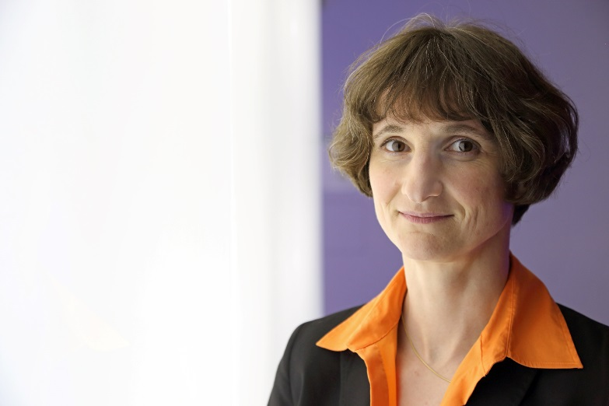Dr. Heike Riel

IBM Fellow

Director Physical Sciences Department

IBM Research

Email: hei@zurich.ibm.com

Biography:

Heike Riel is IBM Fellow and the Director of the Physical Sciences Department at IBM Research focused on advancing the frontiers of information technology through the physical sciences and responsible for IBM's worldwide Physical Science research strategy. Her research interests include nanoscale materials and novel device concepts for applications in electronics, optoelectronics and energy harvesting. Her research focuses on III-V semiconductor nanowires for future nanoelectronics in particular steep slope devices for energy efficient computation.

Heike Riel studied physics at the University of Friedrich-Alexander Erlangen-Nuremberg (Germany) and received a PhD from the University of Bayreuth (Germany) in 2003 for her work on the optimization of multilayer organic light-emitting devices. After an internship at the Hewlett-Packard Research Laboratory, Palo Alto, she joined the IBM Zurich Research Lab in 1998 as a PhD student, and became a Research Staff Member in 2003. From 2008 to 2014 she has been leading the Nanoscale Electronics Group and since 2014 the Materials Integration and Nanoscale Devices group. In 2013 she became IBM Fellow and Member of the IBM Academy of Technology. In 2011 Heike has graduated with an MBA from Henley Business School.

For her outstanding scientific contributions Heike was elected by Technology Review, MIT’s Magazine of Innovation, to the TR100, the annual list of the world’s 100 Top Young Innovators in September 2003 and she received the 2005 Applied Physics Award of the Swiss Physical Society. In June 2012 Heike Riel received the award in the category “Technical or Scientific Innovation” which was awarded by the Swiss Association of Women in Engineering (SVIN) on the occasion of their 20th anniversary. In 2013 she was offered a Humboldt Professorship and in 2015 she was elected Member of the Swiss Academy of Engineering Sciences and elected Member of the Leopoldina, the German National Academy of Sciences. She has authored more than 110 publications and filed more than 50 patents.