Data staging
- Performance and scalability
  - Addressed by separate data-staging service (cache-only service)
- Client tools (arcp extension, sync+async)
- Potentially hot files (job hints?)
  - Cephs no problem
  - Gpfs? Lustre? Independent disks?

Cache technologies:
- Shared FS
- Independent local disks (NFS)
- Squid?
- Cvmfs ?
- Objectstores - investigate the architecture/workflow/feasibility

Data Management/Rucio
- Proof of concept for Rucio+datadelivery+2ARC-CE clusters
  - demonstrator
- Use cases:
  - Single user (small organization) with remote data
  - HPCs with dedicated-to-user (generic) storage, sharedfs or ceph (http)
  - Proposal for a new project (data lake/ocean)

Cache SE:
- Publishing contents to Rucio, mostly done - need to be synced with xcache
- Discuss the job brokering and implement in panda
- Qualification taks?

SE with ceph/object store ...

Use cases:
- HPCs without SE
- Small sites
  - T3s
  - Diskless T2s
Cache sites:
- Without shared FS - pilot mode - xrootd cache - xcache (analogous to squid)
- ARC cache + pilots - access on WNs - cache on demand - jobs request transfer on delivery service

Suggestion:
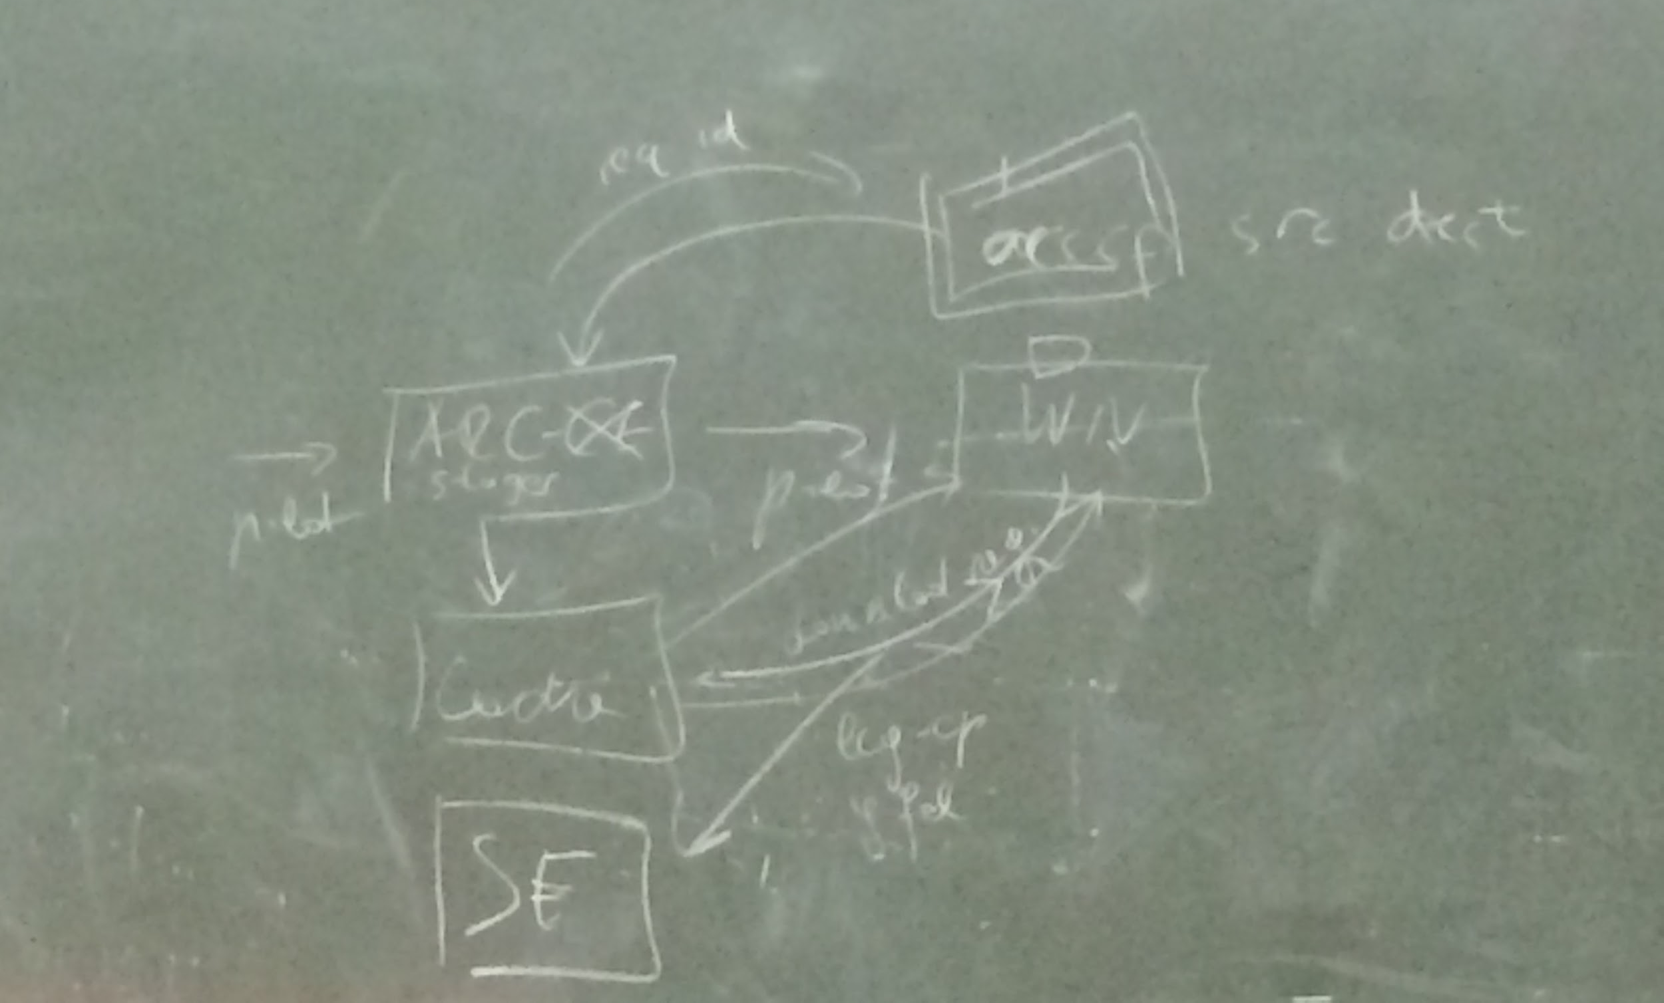
arccp contacts ARC-CE that contacts cache to get file, so arccp will be extended to check cache, if not there, will download the file(s).fts way.
Current implementation is asynchronous
- Check packaging for arccp and arccache service only
- New command instead of arccp

SOAP is (more or less?) ready for use
REST we can think out for the future

- Shared FS
  - ...
- Without shared FS
  - Copy to cache ...
  - Copy to scratch ...

- Synchronous
- Asynchronous
  - Polling, process waiting for i/o - some check status

Service
- A-REX
- Reduced service - dont install arc-ce as arc-ce, just a service to have cache as a service. For e.g. condorCE

Outputs

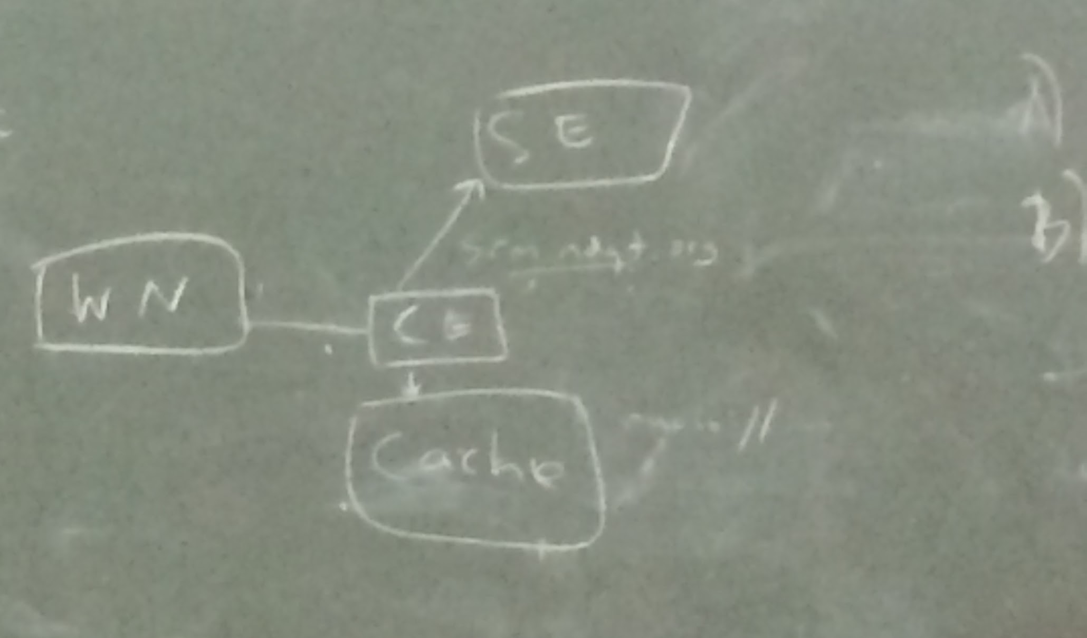
Simple case without registration
ATLAS case: register as rucio

